***Marvel superhero model***

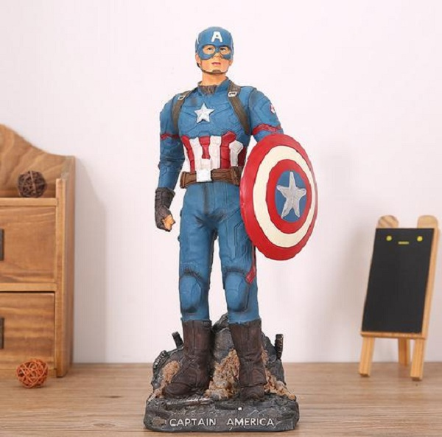

*Marvel superhero model is based on the image of famous characters in the movie adaptations of Marvel's comic books. The product is made of synthetic resin. There are many templates for you to choose from. The product is suitable as a gift for children, children's Tet gifts, or people who love Marvel characters.*